PRESCRIPTION SPECIFICATION

MEDICAL ARCHITECTURAL CONCEPT

**GOODWOOD MOVE**

**Principle**

All rooms will be equipped with a bed head unit such as GOODWOOD MOVE, manufactured by TLV, or an equivalent product :

* incorporating Low voltage/Extra low voltage and medical gas equipment behind a sliding panel that could be installed at the right or at the left of the patient, or even at both sides in order to add a “Hotel aspect” to the hospital room,
* providing general, reading, night and caring lighting for a single or double room, all in one unit, according to the AFE recommendations on the lighting of health establishment.
* protecting the gas outlets with an ABS/PC casing with a cover for AFNOR outlets if necessary,
* including a wide choice of colours to match the colours and furnishings of the rooms.

**Technical reference framework**

*(Image for information only, to illustrate the description)*

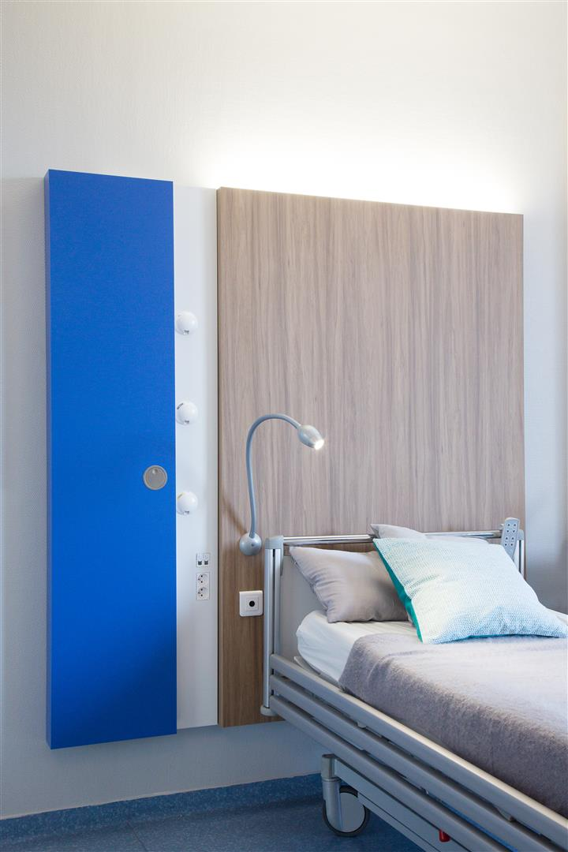

The bed head unit shall be composed of :

* a structure in laminated wood panels with a total thickness of about 20 mm or printable film offering the opportunity to be matched to the decoration of the room,
* a flush-mounted distribution unit made of extruded aluminium profiles, divided into 3 compartments closed by a clip-on cover (natural anodised finish or powder-coated epoxy) for electrical accessories and medical fluids,
* Integrated indirect LED lighting board,
* an optional 25x10mm stainless steel accessory rail for attaching biomedical accessories.

To offer a qualitative aesthetic, the depth of the set (structure & façade panels) shall not exceed 110 mm (without wall or strip lights).

Power supplies and medical fluids will be provided either:

* At the back
* By the ceiling, thanks to an extruded aluminium profile lift with 3 compartments closed by a clip-on cover.

Comportments shall be enclosed up to their connexion point and accessible by opening the front cover to facilitate the maintenance.

Cleaning and disinfection shall be eased thanks to :

* Smooth surfaces
* smoothly moulded ABS/PC faceplates,
* the perfect integration of the external screws,
* electrical accessories flush with the cover.

# **Installation and Maintenance**

They shall be eased thanks to :

* LV connection terminals with identification of the different networks (PC and lighting) with direct snap-in (WAGO type),
* Low-voltage connection terminals with direct snap-in identification (type WAGO),
* a wiring diagram placed inside the duct at the connection point
* a label with the results of the electrical safety tests according to EN-11197 to be placed on the cover inside the duct at the connection terminal
* a system to ensure automatic earthing of the covers
* electrical accessories fixed at the bottom of the duct (not requiring a cleanliness frame)
* ABS/PC medical fluid faceplates integral with the cover integrating the ventilation of the medical fluid compartment for AFNOR sockets

# **Lighting**

They shall be efficient, comfortable and controlled.

Per bed, The GOODWOOD move shall be equipped with :

* 100% direct and indirect lights
* Indirect lighting will be provided by a removable LED plate embedded in the top of the GOODWOOD MOVE and covered by a clear polycarbonate diffuser.
* The reading lighting shall be ensured by a reading spot from the Flex-e-led range.

The structure will be equipped with a LED night light placed at the bottom of each bed.

Considering a maintenance factor of 0.83, the lighting should maintain an average illumination level of at least :

* Ambient : 100 lux at 0.85 m of the floor
* Reading : 300 lux on a 300 x 300 mm at a 75° angle 1.10 m from the ground and 1m from the wall.

Glare from ambient and reading lights will be limited, with the sources not directly visible to the patient, medical staff or visitors, in order to comply with the glare recommendations for workplace lighting.

# **Equipment**

The bed head unit will be composed by an electrical and medical gases equipment for each bed including at least :

* An ambient LED lighting divided in 2 LED modules of 2 Feet with a maintenance class at 50 000 hours L80B10, controlled thanks to a remote.
* A Flex-e-led reading spot, remote controlled
* A night light by 1 Led module, controlled from the room door.
* 4 PC 10/16A+T on 2 separate electrical networks
* 1 RJ45 apply
* A call nurse point and its controller
* 1 pre-tubed oxygen outlet
* 1 pre-tubed medical air outlet
* 1 pre-tubed vacuum outlet

# **Normative framework**

The entire bed head unit manufactured in the factory shall respect the following norms and recommendations:

* EN ISO 9001 and EN ISO 13485: Quality Management Systems,
* CE marking in accordance with the "Medical Devices" directive 93/42/EEC,
* EN ISO 11197: Technical sheaths for medical use,
* EN ISO 7396-1: Medical gas pipeline systems - Part 1,
* AFE recommendations for lighting in health care facilities.

The equipment shall be delivered with the instruction manual detailing the assembly, installation and maintenance operations,