PRESCRIPTION SPECIFICATION
SUSPENDED COLUMN
MULTICARE Evolution

Principle

All beds shall be equipped with a suspended column such as MULTICARE Evolution manufactured by TLV, or an equivalent product:
- incorporating Low voltage/Extra low voltage and medical gas equipment,
- with an anchoring system to fit the building height,
- with a mechanical structure designed to accept an optional lightweight mobile arm (IV pole) and/or caring lighting mounted on an articulated arm, painted with a powdered epoxy coating (RAL 9016 satin white),
- with a compact structure to keep the visual field as clear as possible and provide full access for the patient's head,
- allowing the mounting of a full range of accessories and biomedical devices.
(Image for information only, to illustrate the description)
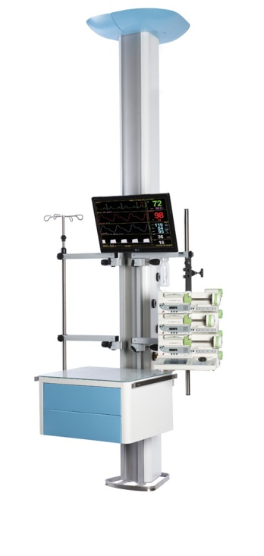
Technical reference framework
The steel anchorage must be able to pass through a false ceiling and shall be equipped with:

- electrical connection terminal blocks,
- column mounting plate,
- casting cover.

The suspended column:

- shall consist of an extruded aluminium profile (fire classification M0) separated into compartments closed by two clipped side covers
- shall be equipped with three vertical accessory mounting rails, 25 x 10 mm, 1500 mm high (two on the front and one on the back),
- shall be able to accommodate one or more trays,
- must support a 200 kg payload.
The trays, designed to comply with the strictest standards concerning hygiene and durability, shall be:

- equipped with a tempered glass or compact with white core (HPL) 6mm thick surface,
- equipped with side accessory mounting rails, section 25x10 mm,
- easily adjustable over the entire height of the column,
- equipped or not with one or two drawers,
- available in two sizes: 400 x 350 mm / 40kg and 600 x 450 mm / 60 kg.

The drawers shall be:

- made of anti-bacterial Kydex,
- equipped with a Push and Lock handle-free opening system,
- removable to facilitate cleaning and disinfection operations,
- available in two sizes: 312 x 283 x 139 mm and 512 x 383 x 139 mm (L x D x H).

Cleaning and disinfection will be easy, thanks to:

- smooth surfaces,
- soft injection moulded endcaps,
- perfect integration of exterior screws,
- electrical accessories flush-mounted with the cover.

The column can optionally be equipped with the following:

- Double-jointed lightweight mobile arm offering:
  - horizontal travel of 850 + 988 mm,
  - vertical travel of approximately 1000 mm,
  - payload capacity of up to 40 kg (including the weight of the distribution box),

- 600 mm high distribution box:

  - shall consist of an extruded aluminium profile separated into compartments closed by two clipped side covers,
  - shall be equipped with one or two Ø38 x 600 mm stainless steel biomedical accessory support tubes,
  - allows the distribution of low voltage and extra-low voltage or medical fluids.

Installation and Maintenance

These will be facilitated by:

- LV connection terminals with identification of the various networks (power socket and lighting) with WAGO-type push wire connectors
- ELV connection terminals with identification with WAGO-type push wire connectors,
- a wiring diagram placed inside the unit near the connection point,
- a label with the results of the EN-11197 electrical safety tests, placed on the cover inside the unit, near the connection terminal block,
- a system providing automatic earthing of the covers,
- electrical accessories secured to the bottom of the column (not requiring a finishing window front frame),

Lighting

The vertical column can optionally be equipped with:

- a LUMIA LED indirect lighting wall unit,
- A FLEX-E LED reading spot lamp on flexible stem,
- LED night light built into the bottom fitting.
- caring lighting, also used for minor surgery, mounted on an articulated arm.

Equipment

The distribution column shall include electrical and medical gas equipment of at least :

- 4 white power sockets on a normal electrical network,
- 4 red power sockets on a backed-up electrical network,,
- 4 equipotential earthing terminals,
- 2 double RJ45 connectors,
- 1 pre-piped oxygen outlet,
- 1 pre-piped medical air outlet,
- 2 pre-piped vacuum outlets,

Normative reference framework

The ceiling-mounted arm, completely factory-made, must comply with the following standards and recommendations in force:

- EN ISO 9001 and EN ISO 13485 : Quality management systems,
- CE Marking in accordance with Directives 93/42/EEC "Medical Devices" and 2006/42/EC "Machines",
- EN ISO 11197 : Special care bed head units,
- EN ISO 7396-1 : Medical gas distribution system - Part 1.

The manufacturer undertakes to provide the following:

- reports on the EN-11197 piping tests,
- reports on the EN-11197 electrical safety tests,
- proof of compliance with the electromagnetic compatibility requirements,
- the EC Medical Devices certificate issued by a notified body,
- the ISO 9001 and ISO 13485 certificates issued by a notified body.

The equipment shall be delivered with the instruction manual giving details of all assembly, installation, and maintenance operations.

