PRESCRIPTION SPECIFICATION

MEDICAL ARCHITECTURAL CONCEPT

**GOODWOOD** with GOODLIGHT lighting unit

**Principle**

All rooms will be equipped with a bed head unit such as GOODWOOD, manufactured by TLV, or an equivalent product :

* incorporating Low voltage/Extra low voltage and medical gas equipment,
* providing general, reading, night and caring lighting for a single or double room, all in one unit,
* protecting the gas outlets with an ABS/PC casing with a cover for AFNOR outlets if necessary,
* including a wide choice of colours to match the colours and furnishings of the rooms.

**Technical reference framework**

*(Image for information only, to illustrate the description)*

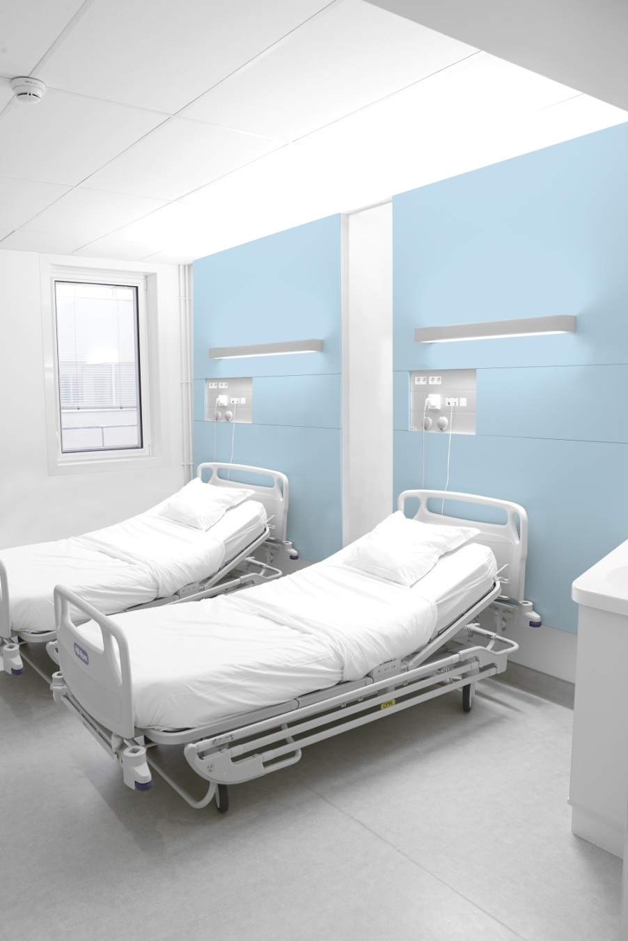 The bed head unit shall consist of:

* a load-bearing structure made of extruded aluminium profile (M0 fire classification) covered in wood-finish panels (M2 fire classification), at least 18 mm thick made of MDF board or 13 mm thick made of HPL board, covered in veneer or a printable film, which gives the opportunity to match it to the decoration of the room,
* a flush-mounted special care bed head unit made of extruded aluminium profiles, divided into three compartments closed by clipped covers (natural anodised finish or powder epoxy paint) for the electricity and medical fluids,
* a GOODLIGHT with aluminium profile wall lighting unit,
* optional stainless steel accessory mounting rail, 25x10mm (optional), to hold biomedical accessories.

For a high-quality aesthetic appearance, the depth of the whole assembly (structure + front panels) must not under any circumstances exceed 93 mm (excluding the wall lighting unit or panel).

The electrical and medical gas supplies will be connected either :

* From behind,
* laterally at the left or right end of the unit, with the other end closed off,
* or from the ceiling, via an extruded aluminium profile duct with three compartments closed by a clipped cover. This can be placed at either end

The compartments will be separated as far as their connection point, and accessible by simply opening the front covers, for ease of maintenance.

Cleaning and disinfection will be easy, thanks to:

* smooth surfaces,
* gas casings made of soft injection moulded ABS/PC,
* perfect integration of exterior screws,
* electrical accessories flush-mounted with the cover.

**Installation & Maintenance**

These will be facilitated by**:**

* LV connection terminals with identification of the various networks (PC and lighting) with WAGO-type push wire connectors,
* ELV connection terminals with identification with WAGO-type push wire connectors,
* a wiring diagram placed inside the unit near the connection point,
* a label with the results of the NF-EN-11197 electrical safety tests, placed on the cover inside the unit, near the connection terminal block,
* a system providing automatic earthing of the covers,
* electrical accessories secured from the back of the unit (not requiring a finishing window front frame),
* ABS/PC medical gas casings securely fastened to the cover or opening, incorporating ventilation of the medical gas compartment for AFNOR outlets.

**Lighting**

Lighting must be high-performance, comfortable, and controlled.

The GOODLIGHT wall lighting unit shall have the following equipment for each bed :

* A panel for general and reading lighting, It will be equipped with high-performance high-efficiency MIRO 20 Silver ® reflectors, directing the light towards the middle of the room and onto the reading surface
* An indirect lighting with clear satin finish PMMA diffuser with anti-UV treatment, and satin-finish polycarbonate diffuser for the direct lighting.

The structure shall be equipped with LED night lighting located in the lower part of the structure.

Allowing for a maintenance factor of 0.83, the lighting units must make it possible to maintain an average lighting level of at least:

* General lighting : 100 lux, 0.85 m above the floor,
* Reading lighting : 300 lux on a 300 x 300 mm plane inclined at 75° located 1.1 m from the floor and 1 m from the wall
* Caring lighting (simple exams) : 300 lux on the bed 0.85 m above the floor (obtained by the addition of general lighting to reading lighting).

The general and reading lights are less likely to dazzle the patient, medical personnel, or visitors, because the sources are not directly visible. This complies with the recommendations concerning bright light in workplaces.

The lighting panel shall be easily removable, for fast replacement and repair out of the room.

**Equipment**

The bed head unit shall incorporate electrical equipment and medical gas terminal units for each bed, with at least:

* a general lighting unit using LED module (3 feet), controlled by remote switch,
* a reading lighting unit using LED module (2 feet), controlled by latching relay,
* night lighting, by one blue LED module, controlled from the entrance door,
* 4 Single power sockets on two separate electrical networks,
* 1 RJ45 socket,
* 1 nurse call button and its handset,
* 1 pre-piped oxygen outlet,
* 1 pre-piped medical air outlet,
* 1 pre-piped vacuum outlet.

**Normative reference framework**

The unit, completely factory-made, must comply with the following standards and recommendations in force:

* EN ISO 9001 and EN ISO 13485: Quality management systems,
* CE Marking in compliance with the 93/42/EEC "Medical Devices" directive,
* EN ISO 11197 : Special care bed head units,
* EN ISO 7396-1 : Medical gas distribution system - Part 1,

The manufacturer undertakes to provide the following :

* reports on the EN-11197 piping tests,
* reports on the EN-11197 electrical safety tests,
* proof of compliance with the electromagnetic compatibility requirements,
* the EC Medical Devices certificate issued by a notified body,
* the ISO 9001 and ISO 13485 certificates,
* the general, lighting, and caring lighting analyses in the context of the installation location of the equipment (a test shall be carried out on the model room if necessary).

The equipment shall be delivered with the instruction manual giving details of all assembly, installation, and maintenance operations.