PRESCRIPTION SPECIFICATION
MEDICAL BED HEAD UNIT
LYSA

Principle

All rooms will be equipped with a horizontal bed head unit such as LYSA, manufactured by TLV, or an equivalent product:
- incorporating Low voltage/Extra low voltage and medical gas equipment,
- providing general, reading, night and caring lighting for a single or double room,
- protecting the gas outlets with an ABS/PC casing with or without a cover according to the outlet standard,
- including a wide choice of colours to match the colours and furnishings of the rooms.
(Image for information only, to illustrate the description)
Technical reference framework

The bed head unit will consist of
- a lighting unit made of extruded aluminium profile (fire classification M0 ) (powder epoxy paint finish) and will have an overall cross-section of 1500 x 165 x 34mm.
- a supply duct made of extruded aluminium profile divided into three compartments closed off by a single clipped cover (powdered epoxy paint finish) for electricity and medical gases, and will have an overall cross-section of 160 x 63 mm. This can be placed on the right or left of the bed.

The electrical and medical gas supplies will be connected either:

- at the back (a cut-out at the back of the unit is provided for this purpose),
- or from the ceiling, via an extruded aluminium profile duct with three compartments closed by a clipped cover. This can be placed at either end.

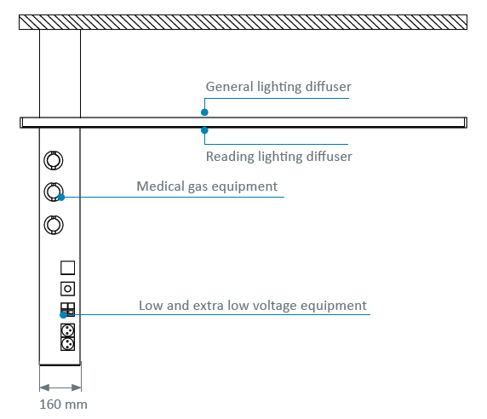

The compartments will be separated as far as their connection point, and accessible by simply opening the covers, one for electricity and one for medical gases for ease of assembly and maintenance.

Cleaning and disinfection will be easy, thanks to :

- endcaps and gas casings made of soft injection moulded ABS/PC
- complete integration of the lighting unit in the profile
- electrical accessories flush-mounted with the cover

Connection to electrical devices will be facilitated by their discreet location on a plane sloped at 20° facing the user.

Installation and Maintenance

These will be facilitated by:

- locking brackets for fast mounting of the unit on the wall,
- LV connection terminals with identification of the various networks (power sockets and lighting) with WAGO-type push wire connectors),
- ELV connection terminals with identification with WAGO-type push wire connectors),
- a wiring diagram placed inside the unit near the connection point,
- a label showing the NF-EN-11197 electrical safety test results , placed on the cover inside the box near the connection terminal,
- a system providing automatic earthing of the covers,
- electrical accessories secured to the bottom of the unit (not requiring a finishing window front frame),
- ABS/PC medical gas casings securely fastened to the cover, incorporating ventilation of the medical gas compartment for AFNOR outlets.

Lighting

Lighting must be high-performance, comfortable, and controlled.

The bed head unit will be equipped with a general lighting panel and a reading lighting wall unit for each bed. These will be equipped with:

- a high-performance, high-efficiency MIRO 20 reflector,
- linear LED modules, macadam 3 Ellipse with 3000 or 4000 K colour temperature and an IRC > 80.

The LED modules have the following characteristics:
- production of light free of ultraviolet and infrared rays, without radiating heat onto the patient requiring the lighting,
- Better orientation of the luminous flux,
- Excellent maintenance of the light flux over time,
- working life up to 50,000 hours, resulting in reduced maintenance costs,
- a higher lumens per watt (lm/W) ratio than lighting that uses fluorescent tube sources.

The diffusers made of PMMA (polymethyl metracrylate) with very high UV resistance (without risk of yellowing) will be attached to the lighting unit, clear for general lighting and satin-finish for reading lighting.

The wall lighting unit shall be equipped with one LED night lighting module per bed in the upper part of the bed head unit, generating a luminous flux of 350 Lm.

Allowing for a lightloss factor of 0.83, the lighting units must make it possible to maintain an average lighting level of at least:

- General lighting : 100 lux, 0.85 m above the floor,
- Reading lighting : 300 lux on a 300 x 300 mm plane inclined at 75° located 1.1 m from the floor and 1 m from the wall
- Caring lighting (simple exams): 300 lux on the bed 0.85 m above the floor (obtained by the addition of general lighting to reading lighting).

The general and reading lights are less likely to dazzle the patient, medical personnel, or visitors, because the sources are not directly visible. This complies with the recommendations concerning bright light in workplaces.

As an option, the bed head unit may be equipped with dynamic LED modules with a colour temperature of 3000 to 6000 K controllable by PLC to reproduce a circadian light cycle.

Equipment

The bed head unit shall comprise one set of equipment for each bed, with at least:

- general lighting by LED module: 4 Ft, 6000 lm, 3000 or 4000 K, 120 lm/W, controlled by remote switch,
- reading lighting by LED module: 2 Ft, 1630 lm, 3000 or 4000 K, 108,5 lm/W, controlled by remote switch,
- night lighting, by one LED module: 350 Lm, 67,5 lm/W, controlled from the entrance door,
- 4 Single power sockets on two separate electrical networks,
- 1 RJ45 socket,
- 1 nurse call button and its handset,
- 1 pre-piped oxygen outlet,
- 1 pre-piped medical air outlet,
- 1 pre-piped vacuum outlet.

Normative reference framework

The unit, completely factory-made, must comply with the following standards and recommendations in force:

- EN ISO 9001 and EN ISO 13485 : Quality management systems,
- CE Marking in compliance with the 93/42/EEC "Medical Devices" directive,
- EN ISO 11197 : Gaines techniques à usage médical,
- EN ISO 7396-1: Medical gas distribution system - Part 1,

The manufacturer undertakes to provide the following:

- reports on the EN-11197 piping tests,
- reports on the EN-11197 electrical safety tests,
- proof of compliance with the electromagnetic compatibility requirements,
- the EC Medical Devices certificate issued by a notified body,
- the ISO 9001 and ISO 13485 certificates,
- the general, lighting, and caring lighting analyses in the context of the installation location of the equipment (a test shall be carried out on the model room if necessary).

The equipment shall be delivered with the instruction manual giving details of all assembly, installation, and maintenance operations.

