PRESCRIPTION SPECIFICATION
CEILING PENDANT
TECH-CARE Ergofix Duo with pneumatic brake

Principle

All workstations shall be equipped with a ceiling-mounted pendant such as TECH-CARE Ergofix Duo manufactured by TLV, or an equivalent product:
- incorporating Low voltage/Extra low voltage and medical gas equipment,
- with an anchorage to fit building height dust-tight casing for non-ventilated false ceilings, as option,
- with a structure able to be equipped with an electrical and medical gas supply column,
- painted with a powdered epoxy coating (RAL 9016 satin white),
- with the standardised colour-coded hoses for medical gases, to be identifiable all along their length,
- allowing the mounting of a full range of accessories and biomedical devices.
(Image for information only, to illustrate the description)
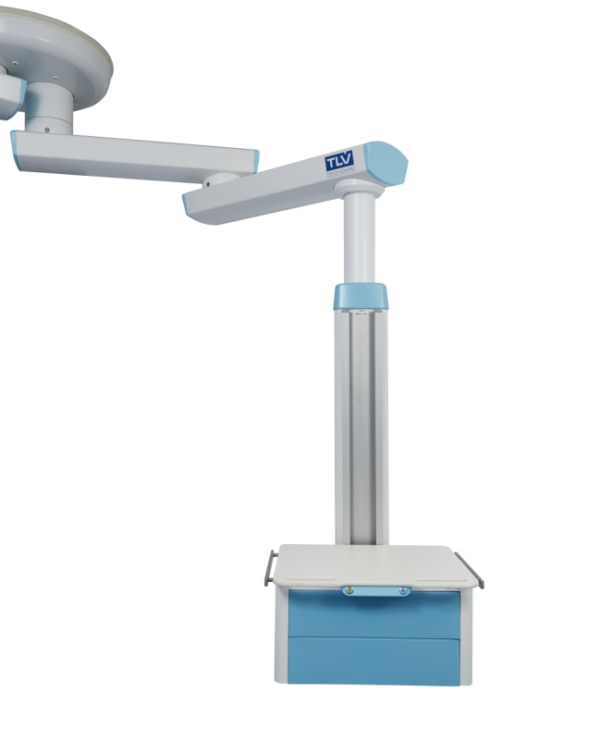
Technical reference framework

The steel anchorage must be able to pass through a false ceiling and shall be equipped with :

- Nist gas connectors,
- electrical connection terminal blocks,
- mounting plate for two articulated arms,
- False ceiling cover.

Each articulated horizontal lifting arm:

- shall consist of a domed extruded aluminium profile (fire classification M0) to limit dust deposition as much as possible, closed at each end by an ABS/PC endcap,
- shall have rotational capability with indexable stops every 15° allowing travel from 30 to 330°,
- shall be equipped with an electropneumatic braking system for the rotation(s) associated with a colour code for intuitive and ergonomic handling of the arms,
- allows the following combinations of lengths : 500 mm, 750 mm, 1000 mm, 500+500 mm, 500+750 mm, 500+1000 mm, 750+750 mm, 750+1000 mm or 1000+1000 mm,
- should support a vertical distribution box able to carry a 150-kg payload.
Each vertical distribution box:
- shall consist of an extruded aluminium profile separated into compartments closed by two clipped side covers,
- shall be equipped with three vertical accessory mounting rails, 25 x 10 mm (two on the front and one on the back),
- shall rotate with a range of movement from 30 to 330°,
- shall be equipped with an adjustable mechanical friction braking system,
- shall be available in three heights : 600, 1200 or 1500 mm,
- shall be able to accommodate one or more trays.

An optional LED night light can be mounted at the bottom of each column.

The trays, designed to comply with the strictest standards concerning hygiene and durability, shall be:
- equipped with a tempered glass or compact with white core (HPL) 6 mm thick surface,
- equipped with side accessory mounting rails, section 25x10 mm,
- easily adjustable over the entire height of the column,
- equipped or not equipped with one or two drawers,
- size 600 x 450 mm / 60 kg.

One of the trays shall be equipped with compact with white core (HPL) 15 mm thick, with built-in handles, and box with laser-engraved illuminated buttons to control the pneumatic brakes.

The drawers shall be :

- made of anti-bacterial Kydex,
- equipped with a Push and Lock handle-free opening system,
- removable to facilitate cleaning and disinfection operations,
- size 512 x 383 x 139 mm (L x D x H).

Cleaning and disinfection will be easy, thanks to :
- smooth surfaces,
- soft injection moulded endcaps,
- perfect integration of exterior screws,
- electrical accessories flush-mounted with the cover.

Installation and Maintenance

These will be facilitated by:

- LV connection terminals with identification of the various networks (power socket and lighting) with WAGO-type push wire connectors,,
- ELV connection terminals with identification with WAGO-type push wire connectors,
- a wiring diagram located inside the box near the connection point,
- a label showing the EN-11197 electrical safety test results , placed on the cover inside the box near the connection terminal block,
- a system providing automatic earthing of the covers,
- electrical accessories secured to the bottom of the box (not requiring a clean environment).

Equipment

The Duo arm shall have at least the following electrical and medical gas equipment for each unit:

Wet side – a distribution box including:
- 4 white power sockets on a normal electrical network,
- 6 red power sockets on a backed-up electrical network,
- 5 equipotential earthing terminals,
- 2 double RJ45 connectors,
- 1 pre-piped oxygen outlet,
- 1 pre-piped medical air outlet,
- 1 pre-piped vacuum outlet,
- One 600x450 mm / 60 kg tray with built-in handles, one or two illuminated buttons to control the pneumatic brakes, one drawer, and 25x10 mm lateral rails.

Dry side – a distribution box including:
- 4 white power sockets on a normal electrical network,
- 4 red power sockets on a backed-up electrical network,
- 4 equipotential earthing terminals
- 1 double RJ45 connector,
- 1 nurse call button and its handset,
- 2 pre-piped oxygen outlets,
- 1 pre-piped medical air outlet,
- 2 pre-piped vacuum outlets,
- One 600x450 mm / 60 kg tray with built-in handles, one or two illuminated buttons to control the pneumatic brakes, two drawers, and 25x10 mm lateral rails.

Normative reference framework

The ceiling-mounted arm, completely factory-made, must comply with the following standards and recommendations in force :

- EN ISO 9001 and NF EN ISO 13485: Quality management systems,
- CE Marking in accordance with Directives 93/42/EEC "Medical Devices" and 2006/42/EC "Machines",
- EN ISO 11197 : Special care bed head units,
- EN ISO 7396-1 : Medical gas distribution system - Part 1.

The manufacturer undertakes to provide the following:

- reports on the EN-11197 piping tests,
- reports on the EN-11197 electrical safety tests,
- proof of compliance with the electromagnetic compatibility requirements,
- the EC Medical Devices certificate issued by a notified body,
- the ISO 9001 and ISO 13485 certificates issued by a notified body.

The equipment shall be delivered with the instruction manual giving details of all assembly, installation, and maintenance operations.

