SPECIFICATIONS

WALL LIGHT

**LUMIA**

**Principle**

All the rooms will be equipped with a LUMIA wall light manufactured by TLV or an equivalent product:

* providing ambient lighting for a room with one bed, with a single device, according to AFE recommendations on healthcare establishment lighting,
* with a wide range of colours: RAL 9006 grey or RAL 9016 white as standard.

*(Visual provided as an indication, to understand the description)*

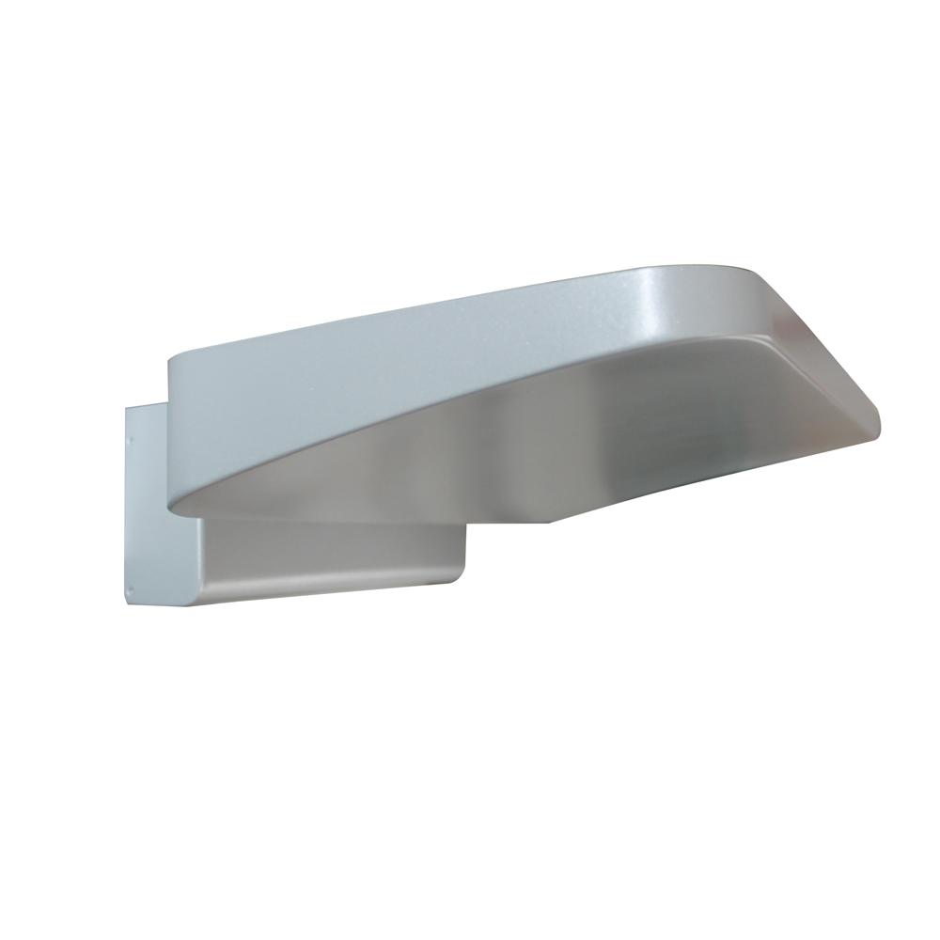

**Technical framework**

The wall light will be composed of a steel body with a powder epoxy paint finish (M0 fire classification), and will have an overall section of 356 x 286 x 86.6 mm.

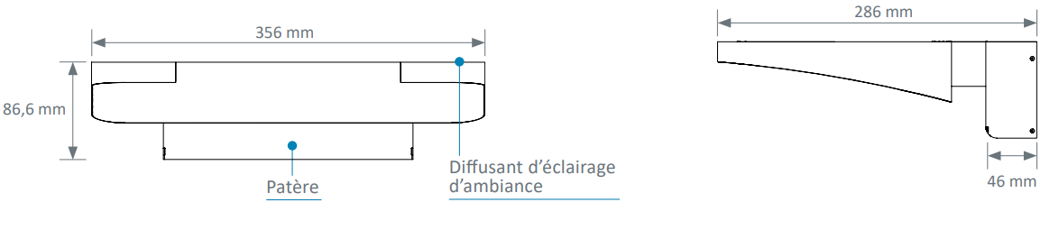

Cleaning and disinfection will be facilitated thanks to:

* smooth surfaces
* rounded shapes,
* the full integration of the lighting system in wall light body.

**Installation**

This will be facilitated by:

* fast assembly on the wall in three steps,
* LV connection terminals with identification of the different lighting networks that click in directly (WAGO).

**Lighting**

This must be efficient, comfortable and controlled.

The wall light will be equipped:

* with an aluminium plate,
* linear LED modules with Macadam Ellipse 3, colour temperature 3,000 or 4,000 K and IRC > 80.

The LED modules will enable:

* light production free from ultra-violet and infrared rays without thermal radiation to the patient to be lit,
* better adjustment of the light flow,
* excellent maintenance of the flow over time,
* a life cycle of up to 60,000 hours, thereby reducing the maintenance costs,
* an lm/W ratio higher than lighting using fluorescent tube sources.

The diffusers made from clear tempered glass will be joined to the wall light body.

Taking into account a maintenance coefficient of 0.83, the ambient lighting must maintain an average lighting level of at least 100 lux at 0.85 from the floor,

The dazzle from the ambient lighting will be limited as the sources are not directly visible to the patient, the medical staff or visitors, to comply with the dazzle recommendations for lighting in the workplace.

The wall light may be equipped as an option with a DALI gradation electronic converter.

**Equipment**

The wall light will be composed of an item of electrical equipment including:

* an ambient light, by 3 Ft, 5,531 lm, 3,000 or 4,000 K, 147.3 lm/W LED module,

**Normative framework**

The wall light is entirely made in a factory and will comply with the following applicable standards and recommendations:

* CE marking according to the applicable provisions of the directive 2014/30/EU 'Electromagnetic compatibility' and the directive 2014/35/EU 'Low Voltage',
* NF EN 60598-1 Lights Part 1 - General requirements and tests,
* NF EN 60598-2-25 Lights for hospital and healthcare establishment treatment units,
* Article EC5 of the safety regulation against fire risks and panic in public access buildings
* AFE recommendations on lighting healthcare establishments.

The manufacturer undertakes to provide:

* the report on electrical safety tests according to EN 60598-1 'Compliance test according to annex Q',
* proof that the electromagnetic compatibility requirements have been met,
* the device CE compliance declaration,
* the lighting studies for ambience, reading and care in the context of installing equipment (if necessary, a test will be performed on the control room).

The equipment will be delivered with the instruction booklet detailing the assembly, installation and maintenance operations.