SPECIFICATIONS
VERTICAL BED HEAT UNIT
FLUIDYS with LUMIA wall light

Principle

All the rooms will be equipped with a FLUIDYS vertical bed head unit with a LUMIA wall light manufactured by TLV or an equivalent product:
- Grouping high-voltage and low-voltage current and medical fluid equipment,
- providing ambient, reading, night and care lighting for a bedroom with 1 or 2 beds with a single device, according to AFE recommendations on healthcare establishment lighting,
- protecting the fluid outlets with a face plate made from ABS/PC with a cover for the AFNOR outlets,
- with a wide range of colours to match different room shades and coverings.

(Visual provided as an indication, to understand the description)

Technical framework
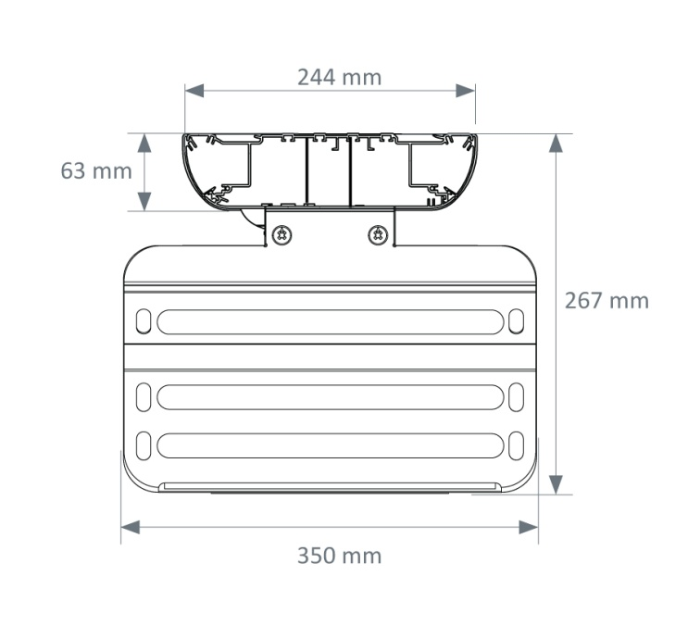
The bed head unit will be composed of an extruded aluminium single-block section (M0 fire classification) divided into 3 compartments closed by one or two clipped covers (powder epoxy paint finish) for electricity and medical fluids and will have a an overall section of 63x244 mm or 324 mm (excluding rails).
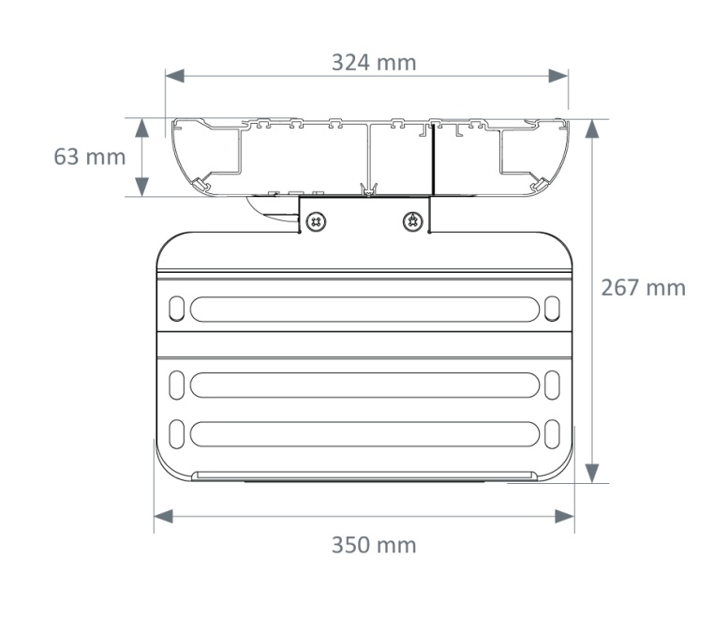
The electricity and medical fluid supplies will either be:

- on the back (there will be a cut at the back of the unit for this purpose),
- through the ceiling a the end of the unit on the top or bottom, the other end being closed by a tip.

The sections may be equipped, as an option, with a 25x10mm accessory support medical rail on the right and/or left to enable the fastening of biomedical accessories and/or (a) drawer tray block(s) of up to 100 kg in payload.

The compartments will be partitioned up to their connection point and accessible on the front by simply opening the cover to facilitate assembly and maintenance.

Cleaning and disinfection will be facilitated thanks to:

- tips and fluid face plates made from ABS/PC moulded in a rounded shape
- electrical accessories flush with the cover

Installation and Maintenance

These will be facilitated by:

- LV connection terminals with identification of the different networks (PC and lighting) that click in directly (WAGO),
- ELV connection terminals with identification that click in directly (WAGO),
- a cabling diagram placed inside the unit by the connection point,
- a label with electrical safety test results according to NF-EN-11197 will be placed on the cover inside the unit on the connection terminal,
- a system to automatically earth the covers,
- electrical accessories fastened at the end of the unit (not requiring a clean frame),
- ABS/PC medical fluid face plates joined to cover incorporating the medical fluid compartment ventilation for AFNOR outlets.

Lighting

This must be efficient, comfortable and controlled.

For each bed, the unit will be equipped with an ambient wall light and a spot on a flex cable for reading.

The ambient wall light will be composed of a powder epoxy paint finish steel body, an aluminium plate equipped with linear LED modules with Macadam Ellipse 3, colour temperature 3,000 or 4,000 K and IRC > 80 and a diffuser made from clear tempered glass.

The LED modules will enable:
- light production free from ultra-violet and infrared rays without thermal radiation to the patient to be lit,
- better adjustment of the light flow,
- excellent maintenance of the flow over time,
- a life cycle of up to 60,000 hours, thereby reducing the maintenance costs,
- an lm/W ratio higher than lighting using fluorescent tube sources.

The reading spot will be composed of a 640 mm flex wire with no rib and an aluminium head with a RAL9016 white paint or anodised finish, equipped with an MR16 LED lamp with the colour temperature 3,000 K.

The bed head unit will be equipped on each bed with a built-in LED night light with a low closing tip.

Taking into account a maintenance coefficient of 0.83, the lighting must maintain an average lighting level of at least:

- Ambience: 100 lux at 0.85 m from the floor,
- Reading: 300 lux on a 300 x 300 plan inclined to 75° situated 1m10 from the floor and 1m from the wall,

The dazzle from the ambient and reading lighting will be limited as the sources are not directly visible to the patient, the medical staff or visitors, to comply with the dazzle recommendations for lighting in the workplace.

Equipment

The bed head unit will be composed of electrical and medical gas equipment on each bed including at least:

- an ambient light, by 3 Ft, 5,531 lm, 3,000 or 4,000 K, 147.3 lm/W LED module, remotely controlled,
- a 292 lm, 4,000 K, 89.8 lm/W reading spotlight, remotely controlled,
- an LED night light built in to the low closure end, controlled from the entrance door,
- 4 PC 10/16A+T on 2 separate electrical networks,
- 1 RJ45 socket,
- 1 nurse call point and its manipulator,
- 1 pretubed oxygen outlet,
- 1 pretubed medical air outlet,
- 1 pretubed vacuum outlet.

Normative framework
The unit is entirely made in a factory and will comply with the following standards, directive and recommendations:
- CE marking in accordance with the medical regulations (2017/745 EU),
- EN ISO 11197: Technical units for medical use,
- EN ISO 7396-1: Medical gas distribution system - Part 1,
- AFE recommendations on lighting healthcare establishments.

The manufacturer undertakes to:
- Provide the tubing test report according to EN ISO 11197 and EN ISO 7396-1,
- Provide the electrical safety test report according to EN ISO 11197 and EN 60601-1,
- Provide proof that the electromagnetic compatibility requirements have been met,
- Provide the valid Medical Device CE certificate issued by a European notified body,
- Provide a CE compliance declaration indicating the device class as well as the name and address of the notified body that has approved the medical device technical file (EN ISO 11197 requirement).
- Provide the ISO 13485 certificates,
- On request, provide the optional lighting studies for ambience, reading and care lighting in the context of installing equipment (if necessary, a test will be performed on the control room).

The equipment will be delivered with the instruction booklet detailing the assembly, installation and maintenance operations (EN ISO 11197 requirement).

