SPECIFICATIONS

NON-MEDICAL WALL LIGHT

**LINA**

**Principle**

All the rooms will be equipped with a LINA wall light manufactured by TLV or an equivalent product:

* Providing ambient, reading, night and care lighting in a room, according to AFE recommendations on healthcare establishment lighting,
* Discreetly grouping within reach a maximum of 6 items of high-voltage and/or low voltage equipment.
* With a wide range of colours to match different room shades and coverings.

*(Visual provided as an indication, to understand the description)***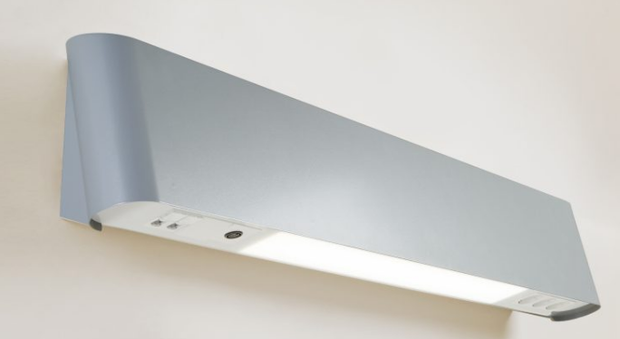**

**Technical framework**

The wall light will be composed of a 1050x140x200mm steel sheet body (M0 fire classification), and will be covered with powder epoxy paint.

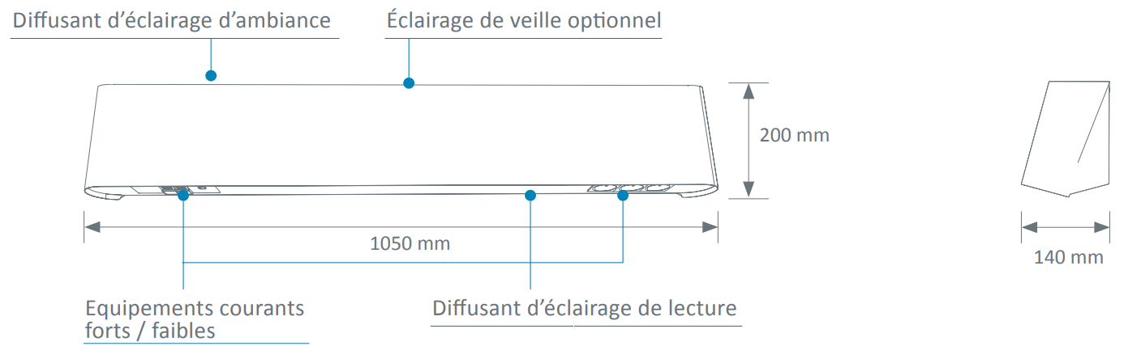

Cleaning and disinfection will be facilitated thanks to:

* Rounded shapes,
* The full integration of the lighting system in wall light body
* Electrical accessories flush with the diffuser.

**Installation and Maintenance**

These will be facilitated by:

* The plate being fastened to the wall with 2 screws.
* Cuts for supply on each side and in the centre of the plate.
* Direct insertion LV connection terminals with identification of the various electrical networks,
* A cabling diagram placed inside the wall light by the connection point,
* Electrical accessories fastened on the plate (not requiring a clean frame).

**Lighting**

The 100% LED lighting must be:

• Efficient:

o Life cycle 60,000 hrs (L80B10), thereby reducing the maintenance costs,

o IRC >80,

o Excellent maintenance of the flow over time,

o An lm/W ratio higher than traditional lighting equipped with fluorescent sources.

• Comfortable:

o Colour temperature 3,000 or 4,000k

o Free from thermal radiation to the patient.

• Equipped:

o Linear LED modules for ambience and reading with at most 3 Macadam Ellipses.

o LED module for nightlight with at most 3 Macadam Ellipses.

Taking into account a maintenance coefficient of 0.83, the lighting must maintain an average lighting level of at least:

• 100 lux for ambient lighting 0.85 from the floor,

• 300 lux for reading lighting on a 300 x 300 plan inclined to 75° situated 1m10 from the floor and 1m from the wall,

• 300 lux on the bed for care lighting 0.85m from the floor (obtained by the combination of ambient and reading lighting).

The diffusers for ambience and reading will be made from PMMA (polymethyl methacrylate) that is extremely resistant to UVs (no risk of yellowing), wand will include reflectors directing the light flow to the centre of the room and the reading surface.

The wall light may be equipped, as an option, with nightlight with an LED module providing a light flow of 335 lm situated in the upper part.

The dazzle from the ambient and reading lighting will be limited as the sources are not directly visible to the patient, the medical staff or visitors, to comply with the dazzle recommendations for lighting in the workplace.

As an option, the wall light may offer indirect lighting equipped with dynamic LED modules with a colour temperature from 2,700 to 6,500 K reproducing a circadian lighting cycle.

**Equipment**

The wall light will comprise one item of equipment per bed including at least:

* An ambient light, by 3 Ft, 4,540 lm, 3,000 or 4,000 K, 142 lm/W LED module, remotely controlled with full flow lighting or Dali gradation impulsion,
* A reading light, by 2 Ft, 2,716 lm, 3,000 or 4,000 K, 137 lm/W LED module, remotely controlled with full flow lighting or Dali gradation impulsion,
* A night light, by 292 lm, 89.8 lm/W LED module, controlled from the entrance door, full flow lighting,
* 2 PC 10/16A+T,
* 1 telephone socket,
* 1 RJ45 socket,
* 1 nurse call point and its manipulator incorporating the lighting and rolling blind controls,
* 1 shutter.

**Normative framework**

The wall light is entirely made in a factory and will comply with the following standards, directives and recommendations:

* CE marking according to directive 2014/35/EU 'low voltage' and 2014/30/EU 'EMC',
* EN 60598-1: Lights 1st part general rules and general information on testing,
* EN 60598-2-25: Lights for hospital and healthcare establishment treatment units,
* AFE recommendations on lighting healthcare establishments.

The manufacturer undertakes to:

* On request, provide the report on electrical safety tests according to EN 60598-1 'Compliance test according to annex Q",
* Provide proof that the electromagnetic compatibility requirements have been met,
* Provide the EU declaration of compliance with the applicable directives,
* On request, provide the lighting studies for ambience, reading and care lighting in the context of installing equipment (if necessary, a test will be performed on the control room).

The equipment will be delivered with the instruction booklet detailing the assembly, use and maintenance operations.