SPECIFICATIONS

SECURE NON MEDICAL WALL LIGHT

**AVOLYS LED**

## Principle

All the rooms will be equipped with an AVOLYS secure wall light manufactured by TLV or an equivalent product:

* providing ambient, reading and night lighting for a room with one bed,
* with a body with no sharp angles and no risk of opening and inserting an object,
* a shock resistance index IK 08 (5 joule shock),
* discreetly grouping within reach a maximum of 8 items of high-voltage and/or low voltage equipment.

*(Visual provided as an indication, to understand the description)*

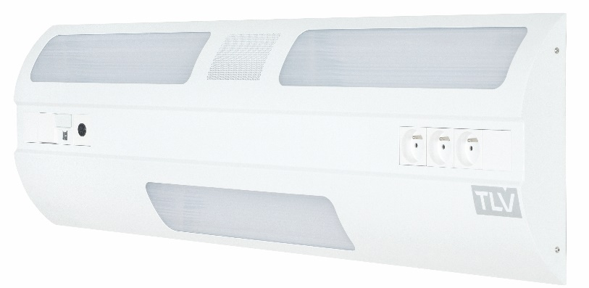

## Technical framework

The wall light will be composed of a 1,050x70x300mm steel sheet body (M0 fire classification), and will be covered with powder epoxy paint.

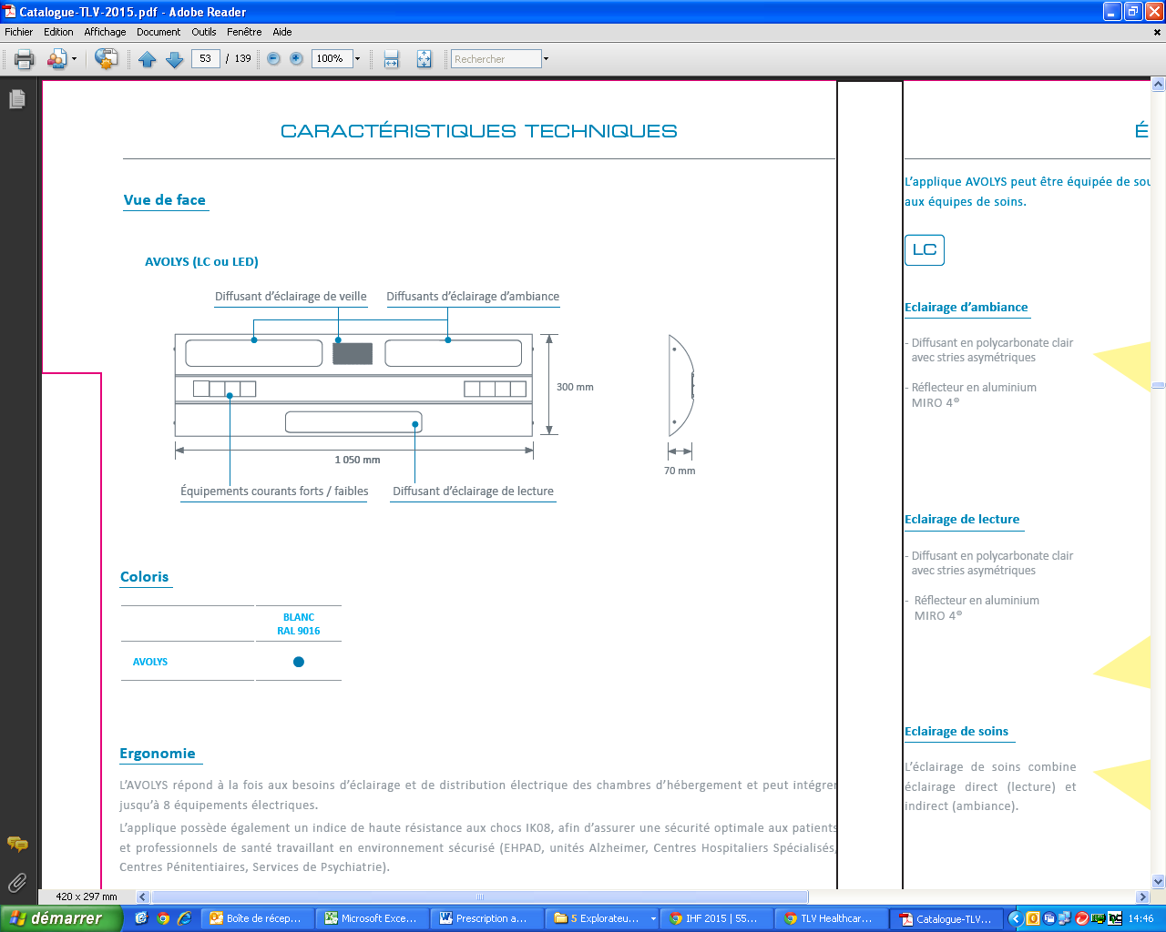

Cleaning and disinfection will be facilitated thanks to:

* rounded shapes,
* the full integration of the lighting system in wall light body

**Installation and Maintenance**

These will be facilitated by:

* LV connection terminals with identification of the different networks (PC and lighting) that click in directly (WAGO),
* A cabling diagram placed inside the wall light by the connection point,
* Electrical accessories that 'clip in' directly to the wall light plate and can be exchanged for shutters.

**Lighting**

The wall light will be equipped with a plate grouping ambient, reading and night lights. It will be equipped with:

* high-yield, high-performance MIRO 20 Silver reflectors, directing the light flows to the centre of the room and the reading surface,
* LEDs with a linear module, Macadam Ellipse 3, colour temperature 3,000K and IRC > 80.

Satin PMMA (polymethyl methacrylate) ambience and reading diffusers that are extremely resistant to UVs (without the risk of yellowing) which will be joined to the wall light body.

The dazzle from the ambient and reading lighting will be limited as the sources are not directly visible to the patient, the medical staff or visitors.

The wall light may be equipped as an option with a DALI gradation electronic converter.

**Equipment**

The wall light will be composed of an item of electrical equipment including at least:

* an indirect light, by 2 Ft, 3,771 lm, 3,000 or 4,000 K, 145 lm/W LED module, remotely controlled,
* a direct light, by 1 Ft, 1,481 lm, 3,000 or 4,000 K, 145 lm/W LED module, remotely controlled,
* A night light, by one 292 lm, 3,000 K, 89.8 lm/W LED module, controlled from the entrance door,
* 2 PC 10/16A+T on a normal network,
* 1 telephone socket,
* 1 nurse call point and its manipulator,
* 4 shutters

## Normative framework

The wall light is entirely made in a factory and will comply with the following applicable standards and recommendations:

* CE marking according to the applicable provisions of the directive 2014/30/EU 'Electromagnetic compatibility' and the directive 2014/35/EU 'Low Voltage',
* NF EN 60598-1 Lights Part 1 - General requirements and tests,
* NF EN 60598-2-25 Lights for hospital and healthcare establishment treatment units,
* Article EC5 of the safety regulation against fire risks and panic in public access buildings.

The manufacturer undertakes to provide:

* the report on electrical safety tests according to EN 60598-1 'Compliance test according to annex Q',
* proof that the electromagnetic compatibility requirements have been met,
* the device CE compliance declaration,
* the lighting studies for ambience, reading and care in the context of installing equipment (if necessary, a test will be performed on the control room).

The equipment will be delivered with the instruction booklet detailing the assembly, installation and maintenance operations.