SPECIFICATIONS

NON-MEDICAL WALL LIGHT

**LYSA**

**Principle**

All the rooms will be equipped with a LYSA wall light manufactured by TLV or an equivalent product:

* grouping high-voltage and low-voltage current equipment,
* providing ambient, reading, night and care lighting for a bedroom with 1 or 2 beds with a single device, according to AFE recommendations on healthcare establishment lighting,
* with a wide range of colours to match different room shades and coverings.

*(Visual provided as an indication, to understand the description)*

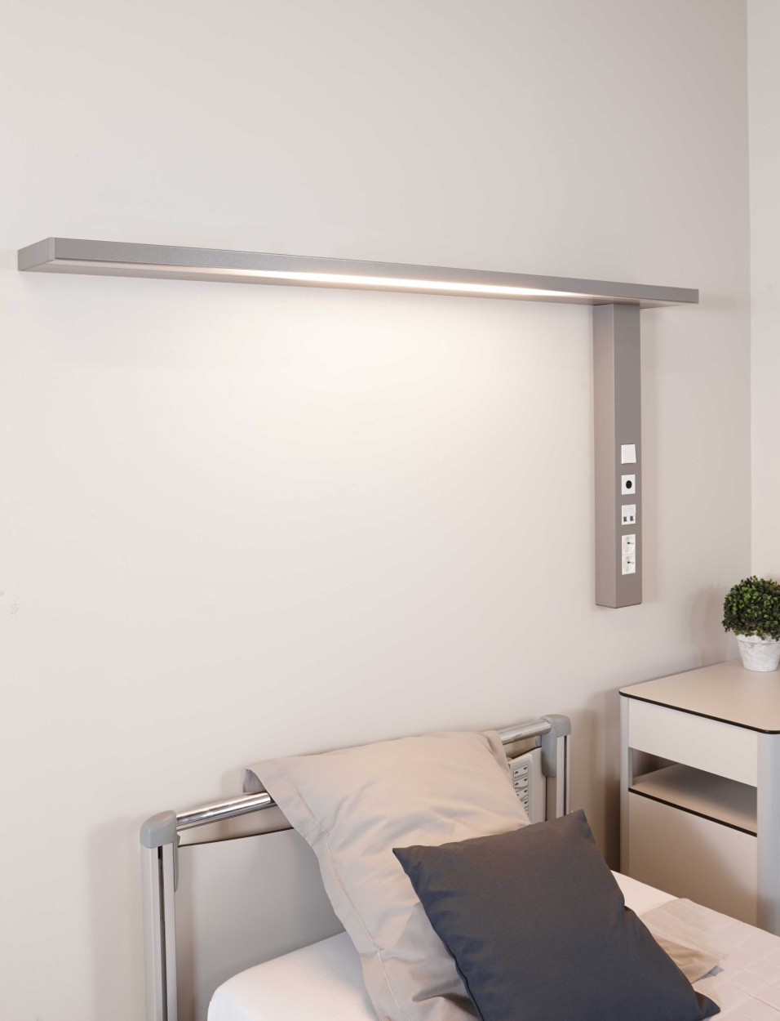

**Technical framework**

The bed head unit will comprise:

* a wall light made of an extruded aluminium section (M0 fire classification) (powder epoxy paint finish) and will have an overall section of 1500 x 165 x 34 mm,
* a descent also made from extruded aluminium divided into 2 compartments (powder epoxy paint finish), closed by a single clipped cover for the high- and low-voltage current electricity and will have an overall section of 92 x 63 mm. This may be placed to the right or left of the bed.

The electrical supplies will be on the back (a cut at the back of the descent will be made for this purpose).

The compartments will be partitioned up to their connection point and accessible on the front by simply opening the cover to facilitate assembly and maintenance.

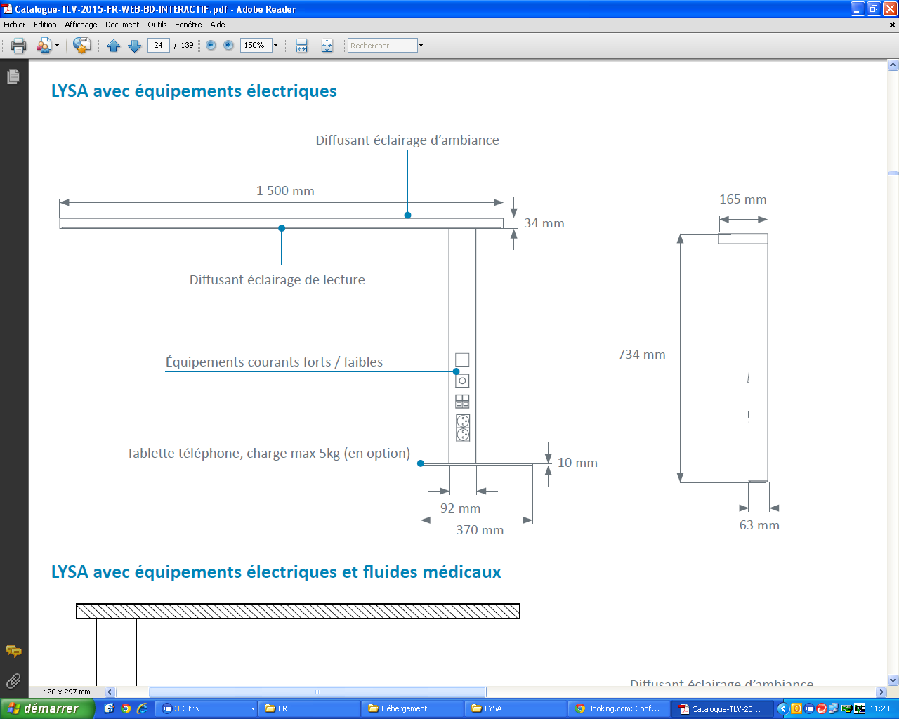

Cleaning and disinfection will be facilitated thanks to:

* Rounded moulded ABS/PC ends,
* the full integration of the lighting system in the section,
* electrical accessories flush with the cover.

**Installation and Maintenance**

These will be facilitated by**:**

* suspension brackets to fasten the light to the wall quickly,
* LV connection terminals with identification of the different networks (PC and lighting) that click in directly (WAGO),
* ELV connection terminals with identification that click in directly (WAGO),
* a cabling diagram placed inside the unit by the connection point,
* a label with electrical safety test results according to NF-EN-11197 which will be placed on the cover inside the unit on the connection terminal,
* a system to automatically earth the covers,
* electrical accessories fastened at the end of the unit (not requiring a clean frame).

**Lighting**

The 100% LED lighting must be:

• **Efficient**:

o Life cycle 60,000 hrs (L80B10), thereby reducing the maintenance costs,

o IRC >80,

o Excellent maintenance of the flow over time,

o An lm/W ratio higher than traditional lighting equipped with fluorescent sources.

• **Comfortable**:

o Colour temperature 3,000 or 4,000k.

o Free from thermal radiation to the patient.

• **Equipped**:

o Linear LED modules for ambience and reading with at most 3 Macadam Ellipses.

o LED module for nightlight with at most 3 Macadam Ellipses.

On each bed, the GOODLIGHT wall light will be equipped with:

* high-yield, high-performance MIRO 20 Silver ® reflectors, directing the light flows to the centre of the room and the reading surface,
* an indirect lighting diffuser made from clear satin PMMA (polymethyl methacrylate) with an anti-UV treatment and a direct lighting diffuser made from satin polycarbonate

The structure will be equipped on each bed with an LED night light situated on the lower part of the structure.

Taking into account a maintenance coefficient of 0.83, the lighting must maintain an average lighting level of at least:

* Ambience: 100 lux at 0.85 m from the floor,
* Reading: 300 lux on a 300 x 300 plan inclined to 75° situated 1m10 from the floor and 1m from the wall,
* Care (simple examinations): 300 lux on the bed at 0.85m from the floor (obtained by the combination of ambient and reading lighting).

The dazzle from the ambient and reading lighting will be limited as the sources are not directly visible to the patient, the medical staff or visitors, to comply with the dazzle recommendations for lighting in the workplace.

As an option, the indirect lighting may be equipped with dynamic LED modules with a colour temperature from 2,700 to 6,500 K reproducing a circadian lighting cycle.

**Equipment**

The bed head unit will be composed of electrical and medical gas equipment on each bed including at least:

* an ambient light, by 4 Feet, 6,255 lm, 3,000 or 4,000k, 153.4 lm/W LED module, remotely controlled,
* a reading light by 2 Feet, 1,710 lm, 3,000 or 4,000k, 158.8 lm/W LED module, remotely controlled,
* A night light, by 292 lm, 89.8 lm/W LED module, controlled from the entrance door, full flow lighting,
* 4 PC 10/16A+T on 2 separate electrical networks,
* 1 RJ45 socket,
* 1 nurse call point and its manipulator,

**Normative framework**

The unit is entirely made in a factory and will comply with the following applicable standards and recommendations:

* CE marking according to the applicable provisions of the directive 2014/30/EU 'Electromagnetic compatibility' and the directive 2014/35/EU 'Low Voltage',
* NF EN 60598-1 Lights Part 1 - General requirements and tests,
* NF EN 60598-2-25 Lights for hospital and healthcare establishment treatment units,
* Article EC5 of the safety regulation against fire risks and panic in public access buildings
* AFE recommendations on lighting healthcare establishments.

The manufacturer undertakes to provide:

* the report on electrical safety tests according to EN 60598-1 'Compliance test according to annex Q',
* proof that the electromagnetic compatibility requirements have been met,
* the device CE compliance declaration,
* the lighting studies for ambience, reading and care in the context of installing equipment (if necessary, a test will be performed on the control room).

The equipment will be delivered with the instruction booklet detailing the assembly, installation and maintenance operations.