SPECIFICATIONS

WALL LIGHT

**GOODLIGHT LED**

## Principle

All the rooms will be equipped with a GOODLIGHT LED wall light manufactured by TLV or an equivalent product:

* providing ambient lighting for reading and care in a room with one bed, with a single device, according to AFE recommendations on healthcare establishment lighting,
* with a wide range of colours: RAL 9006 grey as standard or choice of RAL colour on request.

*(Visual provided as an indication, to understand the description)*

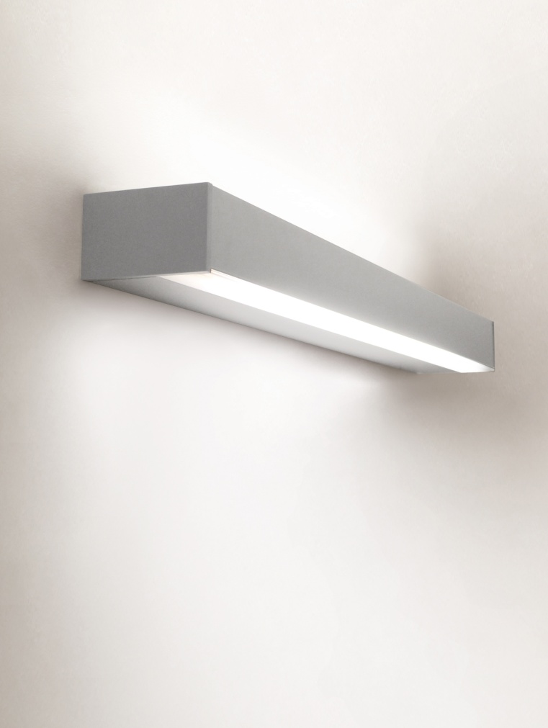

## Technical framework

The wall light will be composed of a 950x120x75mm aluminium section body (M0 fire classification), and will be covered with powder epoxy paint.

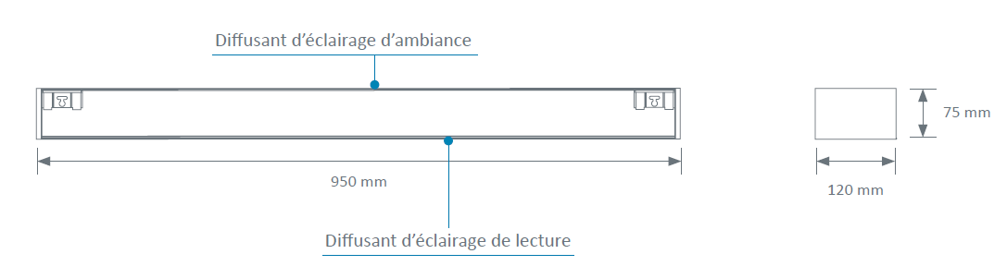

Cleaning and disinfection will be facilitated thanks to:

* smooth surfaces
* rounded shapes,
* the full integration of the lighting system in wall light body

**Installation**

This will be facilitated by:

* a rapid fastening bracket on the wall,
* LV connection terminals with identification of the different lighting networks that click in directly (WAGO).

**Lighting**

The 100% LED lighting must be:

• **Efficient**:

o Life cycle 60,000 hrs (L80B10), thereby reducing the maintenance costs,

o IRC >80,

o Excellent maintenance of the flow over time,

o An lm/W ratio higher than traditional lighting equipped with fluorescent sources.

• **Comfortable**:

o Colour temperature 3,000 or 4,000k.

o Free from thermal radiation to the patient.

• **Equipped**:

o Linear LED modules for ambience and reading with at most 3 Macadam Ellipses.

o LED module for nightlight with at most 3 Macadam Ellipses, situated in the upper part of the wall light.

The wall light will be equipped with:

* High-yield, high-performance MIRO 20 Silver reflectors, directing the light flows to the centre of the room and the reading surface,
* A clear PMMA (polymethyl methacrylate) ambience diffuser that is extremely resistant to UVs (without the risk of yellowing) which will be joined to the wall light body.
* A satin polycarbonate reading diffuser that will be joined to the wall light body.

The dazzle from the ambient and reading lighting will be limited as the sources are not directly visible to the patient, the medical staff or visitors, to comply with the dazzle recommendations for lighting in the workplace.

The wall light may be equipped as an option with a DALI gradation electronic converter.

Taking into account a maintenance coefficient of 0.83, the lighting must maintain an average lighting level of at least:

* Ambience: 100 lux at 0.85 m from the floor,
* Reading: 300 lux on a 300 x 300 plan inclined to 75° situated 1m10 from the floor and 1m from the wall,
* Care (simple examinations): 300 lux on the bed at 0.85m from the floor (obtained by the combination of ambient and reading lighting).

**Equipment**

The wall light will be composed of an item of electrical equipment including:

* an indirect light, by 3 Ft, 5,039 lm, 3,000 OR 4,000 K, 151.9 lm/W LED module,
* a direct light, by 2 Ft, 1,710 lm, 3,000 OR 4,000 K, 158.8 lm/W LED module,
* a night light by a 292 lm, 3,000 K, 89.8 lm/W LED module.

## Normative framework

The wall light is entirely made in a factory and will comply with the following applicable standards and recommendations:

* CE marking according to the applicable provisions of the directive 2014/30/EU 'Electromagnetic compatibility' and the directive 2014/35/EU 'Low Voltage',
* NF EN 60598-1 Lights Part 1 - General requirements and tests,
* NF EN 60598-2-25 Lights for hospital and healthcare establishment treatment units,
* Article EC5 of the safety regulation against fire risks and panic in public access buildings
* AFE recommendations on lighting healthcare establishments.

The manufacturer undertakes to provide:

* the report on electrical safety tests according to EN 60598-1 'Compliance test according to annex Q',
* proof that the electromagnetic compatibility requirements have been met,
* the device CE compliance declaration,
* the lighting studies for ambience, reading and care in the context of installing equipment (if necessary, a test will be performed on the control room).

The equipment will be delivered with the instruction booklet detailing the assembly, installation and maintenance operations.